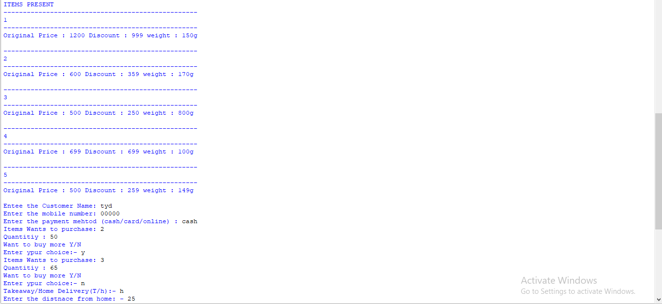

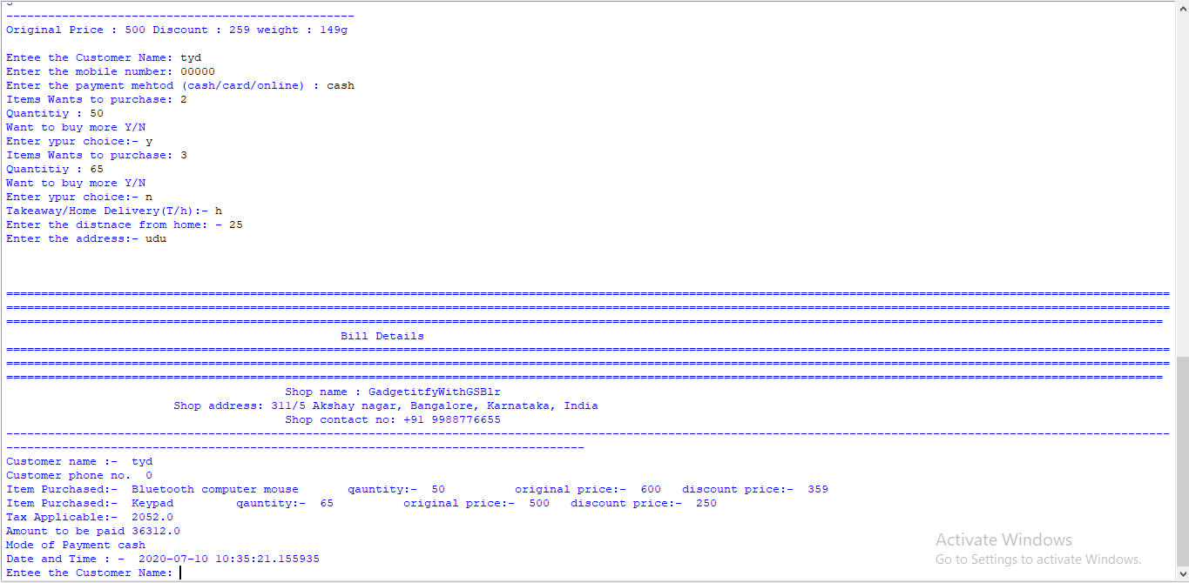

The Whole Code is written in Python 3.8.2 in python IDE only.

1. Here I took the help of nested dictionary(dictionary within a dictionary) concept to store the item list present in the shop. I Stored the . items with their amount as key:value pair in the dictionary.
2. To more variable by the name “num” and “mapping” is used just to ease the user to enter the input in numerical form and the map the result with the desired input.
3. First I stored 5 items with lots of different details about the product like discount and weight in dictionary and stored the list in a variable by name “shoplist”.
4. Used a while loop if the user may want to deal with more then one customer , then the program can be modified easily just by removing the break command at the end the code.
5. Took the input from the user about the customer name and all. The presented them with the list of items present with simple use for loop
6. Used a if condition just in case user need to buys more then one item form the shop.
7. In the ui user is asked for a takeaway or home delivery option using if else condition I have move forward.
8. Several if else are used for differentiation of distance, a delivery boy/girl has to travel depending upon that different amount is fixed.
9. Calculation of tax is done with 6% tax on total amount i.e (6/100)\*total amount
10. The line with “\n\n” is used only to change lines nothing else.
11. Then the next three line is used for printing the details of the shop with the basic print statement.
12. Then all the details of the customer is printed along with the Item he/she bought from the store.
13. For getting the system time I imported date, time,datetime from a module datetime, and now uis used for formatted time with YYYY-MM-DD HH:MIN:SEC.